Bugs and Errors Report # 7

URL: <https://takingmyclassesonline.com>

Point # 1:

Homepage:  
Today’s world is moving towards virtual opportunities. With the advent of AI, technology, and better internet connections worldwide, taking online classes has become common. You can enrol in an online class anywhere. If you write on Google ‘[do my exam online](https://takingmyclassesonline.com/take-my-exam)’ , you will find a number of services. You only need a laptop and an internet connection to access the classes. Moreover, we now witness virtual universities offering online courses instead of virtual classes. Lastly, this evaluation signifies the value of online classes.

* Note: ‘do my exam online’, (remove gap between single quote ‘ and comma ,)

URL # 2: <https://takingmyclassesonline.com/pte-academic-online>

No

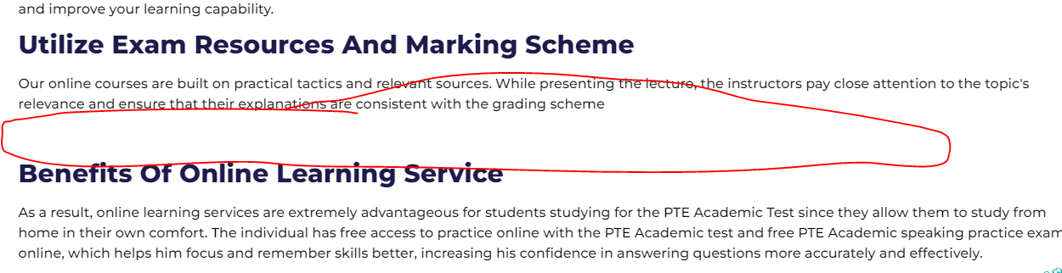

Still Gap between both the paragraphs.

URL 3: <https://takingmyclassesonline.com/pay-someone-to-take-my-class>

conduct many mock tests including,[mock LSAT exam](https://takingmyclassesonline.com/lsat-exam-prep), LPN mock test and much

, [mock LSAT exam](https://takingmyclassesonline.com/lsat-exam-prep)  
Note: you have to put space after the , comma

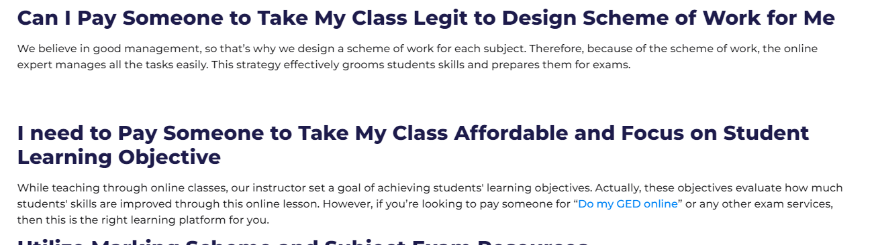

Note: gap between the both paragraphs.